“I Can’t Punch in Workday when using Mobile”

As of: 9/14/22

## **Introduction**

This is an attempt to clarify the use and management of Service Now tickets related Punching in and out using the workday Mobile app.

There are 2 items we need to address.

1. Corrections to some of the category setting in ServiceNow for initial and secondary assignment.
2. A process for determining what the issue is and how to resolve it.

## **ServiceNow**

There are 2 subcategories and 2 Assignment groups. 3 are assigned to Kathryn Roberts and 1 is assigned to Maria Norton.

Ideally, any calls or tickets related to Punching in or out with the mobile app will first go to the helpdesk so an initial review can be done.

There are a couple of the scenarios that the helpdesk can help the caller resolve. If those do not work then they can help refine the problem, gather some additional info, and then pass it to HR.

In this case, passing it to HR, means getting it to Anna Pfaff who has permissions in Workday to make location information changes.

*What is the best way to implement this 2-tier approach in ServiceNow?*

*Need to work with John Duchock for options.*

## **Problem Assessment and Resolution Options**

Here is a draft approach to determining next steps with a call/ticket. Workflow to the right. Details for the Help desk “Assessment Questions / Actions” are in the table below.

| **STEP** | **Question / Action** | **Response / Action** | **Next Step** |
| --- | --- | --- | --- |
| **1** | Are you the only one in the store having trouble Punching with Mobile Workday App? | Yes | 1.1 |
|  |  | No | 1.2 |
| **1.1** | Have you tried from different locations in the store, including near the register? | Yes | 1.3 |
|  |  | No | 1.4 |
| **1.2** | Is this a problem with SOME or ALL of you in the store? | Some.  Have them all go through the steps starting with 1.1 | 1.1 |
|  |  | All | 1.5 |
| **1.3** | Let’s make sure your Location Services are turned on for the Workday App to use.  **iPhone**  Go to Settings > Go to Privacy  Go to Location Services.  >> Is “Location Services” On?  **Android**  Go to … | Yes | 1.7 |
|  |  | No.  Turn it on.  Close the Workday App  Open the Workday App | 1.7 |
| **1.4** | Move near the Register.  Try it now. Does it work? | Yes | END |
|  |  | No | 1.3 |
| **1.5** | Are you a new store or recently relocated? | Yes.  Have them give you their new complete mailing Address.  *IF MALL location*, also have them describe “when facing the store entrance name of the store on the left, the store on the right, and the store behind them (the store facing across from our store).” | 2 |
|  |  | No. | 1.6 |
| **1.6** | Let’s use your phone to get your current location coordinates. | * Have the caller or manager stand by the register. * Use these instructions to collect the Store’s coordinates. | 3 |
| **1.7** | Is it working now? | Yes.  Resolve Ticket. | END |
|  |  | No | 1.8 |
| **1.8** | Reinstall the App.  Delete app from device.  *While reinstalling, when it asks about knowing your locations*, select:   * Yes, or * While in use   >> Does it work now? | Yes.  Resolve Ticket. | END |
|  |  | No. | 1.9 |
| **1.9** | Can you use other functions in the Workday App? | Yes.  For a reason we cannot determine, your phone is not sharing *location* information with Workday. There are no other actions we can take.  You will need to use the POS.  Close ticket. | END |
|  |  | No.  This should mean the employee is not set up completely in Workday. | 2 |
| **2** | Provide the new information to HR.   * New address info, or * New Coordinates, or * Employee status in system may be wrong | Assign ticket to  Workday – Clock-in Clock-out | END |

# **Where is my store? Finding your Longitude and Latitude on your phone.**

**iPhone**

* Go to Maps
* It should open showing where you are (the Blue dot). If it doesn’t then tap on the “find me” pointer.
* Tap on the Blue Dot to get details about that location. (Details are in the lower half of the screen)
* Slide the bottom portion of the screen up some and you will see

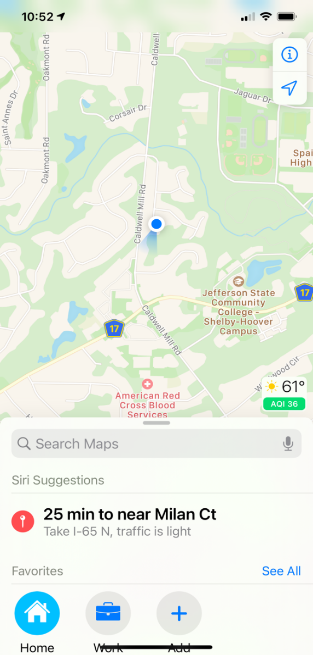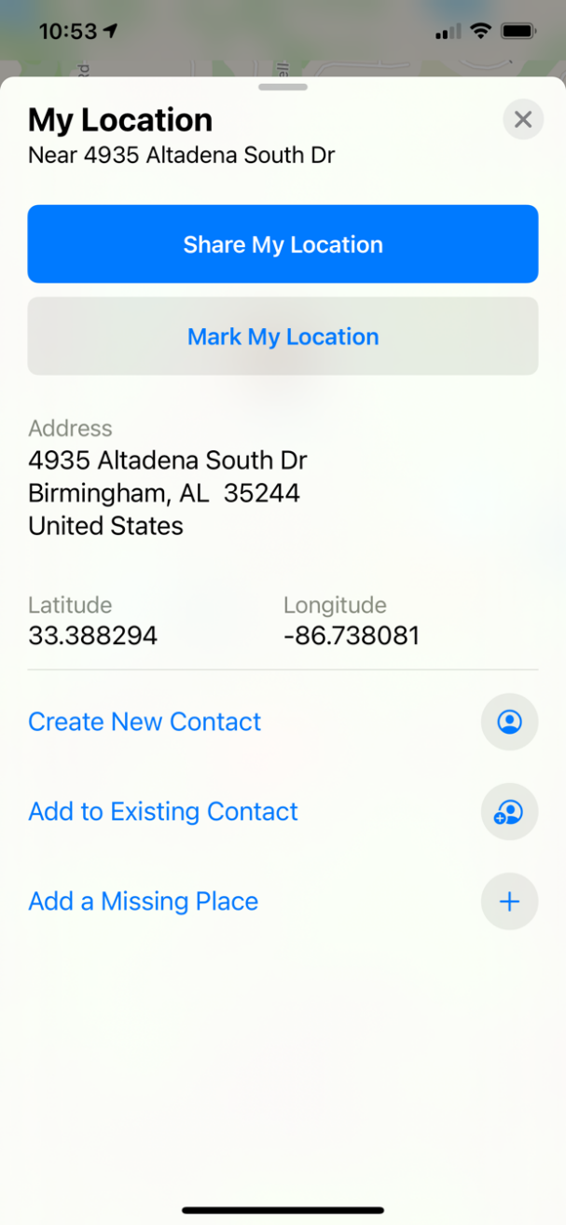

**Android**

* Go to Google Maps
* Hold your finger down on the Blue dot, until the Red Pin shows like in the picture.
* Then slide the bottom part of the screen up and see the coordinates. As in the picture below.

